**Print unique values of a dict:**

CODE:

games_studios = {}  
  
games_studios['The Witcher 3'] = 'CD Projekt Red'  
games_studios['Red Dead Redemption 2'] = 'Rockstar Games'  
games_studios['Grand Theft Auto 5'] = 'Rockstar Games'  
games_studios['The Last of Us Part II'] = 'Naughty Dog'  
games_studios['Cyberpunk 2077'] = 'CD Projekt Red'  
  
unique_studios = {studio for studio in games_studios.values()}  
  
print("Unique studios:")  
print(unique_studios)

OUTPUT:

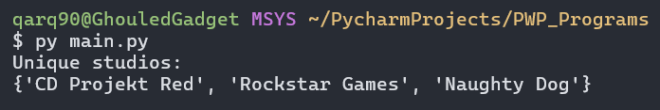

**Find Max and Min in a set:**

CODE:

my_dict = {'K1': 365, 'K2': 1561, 'K3': 912, 'K4': 512, 'K5': 34}  
  
items = list(my_dict.items())  
  
n = len(items)  
for i in range(n - 1):  
 for j in range(n - i - 1):  
 if items[j][1] > items[j + 1][1]:  
 items[j], items[j + 1] = items[j + 1], items[j]  
  
sorted_dict = dict(items)  
  
print("Sorted dictionary by values:")  
for key, value in sorted_dict.items():  
 print(key, ":", value)  
  
largest = items[0]  
second_largest = items[1]  
third_largest = items[2]  
  
print("Largest:", largest)  
print("Second Largest:", second_largest)  
print("Third Largest:", third_largest)

OUTPUT:

